DAY 6

Homework Update for Menu API

- Task To create POST /menu and GET /menu

- We are now creating a POST method to save menu details and it’s similar to person details and the same for the GET method

Flow Diagram of API

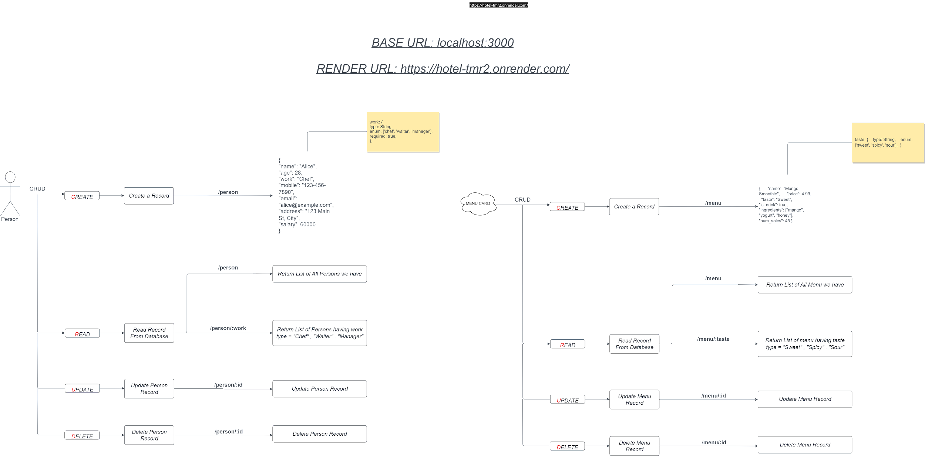

https://drive.google.com/file/d/1TswAyCgfsa04Hp6f4OP-Umg_GVkdW4eQ/view?usp=sharing

Parametrised API calls

- Now if someone told you to give a list of people who are only waiters
- Then we can create an endpoint like this

- /person/chef
- /person/waiter
- /person/manager

- But this is not the correct method to create as many functions Here we can use parametrized endpoints
- It can be dynamically inserted into the URL when making a request to the API.

- localhost:3000/person/:work

→ work = [ “chef”, “waiter”, “manager” ]

app.get('/person/:work', async (req, res) => {
try {
const workType = req.params.work; // Extract the work type from the URL parameter
// Assuming you already have a Person model and MongoDB connection set up
const persons = await Person.find({ work: workType });
// Send the list of persons with the specified work type as a JSON response
res.json(persons);
} catch (error) {
console.error('Error fetching persons:', error);
res.status(500).json({ error: 'Internal server error' });
}
});

Express Router

- We have lots of Endpoints in a single file server.js
- This makes bad experience in code readability as well as code handling
- Express Router is a way to modularize and organize your route handling code in an Express.js application.
- So let’s create a separate file to manage endpoints /person and /menu
- Express Router is like a traffic cop for your web server
- Express Router helps you organize and manage these pages or endpoints in your web application. It's like creating separate folders for different types of tasks.

- Create a folder routes → personRoutes.js
const express = require('express');
const router = express.Router();
// Define routes for /person
router.get('/', (req, res) => {
// Handle GET /person
});
router.post('/', (req, res) => {
// Handle POST /person
});
module.exports = router;

- Now in server.js, we will use this personRoutes
// Import the router files
const personRoutes = require('./routes/personRoutes');
// Use the routers
app.use('/person', personRoutes);

Update Operation

- We will update our person Records, and for that, we will create an endpoint from where we are able to update the record
- For Updation, we need two things
  - Which record we want to update?
  - What exactly do we want to update?
- For update, we will use the PUT method to create an endpoint
- What is a unique identifier in a document in a collection?
- It’s _id which Mongodb itself gives, We will use this to find the particular record that we want to update
- —> And now we will send the data the same as we did in the POST method.

app.put('/person/:id', async (req, res) => {
try {
const personId = req.params.id; // Extract the person's ID from the URL parameter
const updatedPersonData = req.body; // Updated data for the person
// Assuming you have a Person model
const updatedPerson = await Person.findByIdAndUpdate(personId, updatedPersonData, {
new: true, // Return the updated document
runValidators: true, // Run Mongoose validation
});
if (!updatedPerson) {
return res.status(404).json({ error: 'Person not found' });
}
// Send the updated person data as a JSON response
res.json(updatedPerson);
} catch (error) {
console.error('Error updating person:', error);
res.status(500).json({ error: 'Internal server error' });
}
});

Delete Operation

- We will Delete our person Records, and for that we will create an endpoint from where we are able to delete the record
- For Deletion, we need one thing
  - Which record we want to update?
- For deletion, we will use the DELETE method to create an endpoint
- What is a unique identifier in a document in a collection?
- It’s _id which Mongodb itself gives, We will use this to find the particular record that we want to delete

app.delete('/person/:id', async (req, res) => {
try {
const personId = req.params.id; // Extract the person's ID from the URL parameter
// Assuming you have a Person model
const deletedPerson = await Person.findByIdAndRemove(personId);
if (!deletedPerson) {
return res.status(404).json({ error: 'Person not found' });
}
// Send a success message as a JSON response
res.json({ message: 'Person deleted successfully' });
} catch (error) {
console.error('Error deleting person:', error);
res.status(500).json({ error: 'Internal server error' });
}
});

